Name: Jorune Simpkins
Lab: Lab 2a
Document Topic: Student Deliverables
Date: 2/4/2026

Verification CLI (students must prove all 3 requirements)
1) “VPC is only reachable via CloudFront”
A) Direct ALB access should fail (403)
curl -I https://<ALB_DNS_NAME>
OUTPUT:
jorun@Simpkij3421 MINGW64 ~/documents/theowaf/armageddon/armageddon_repo/armageddon_clone/lab2_2a (main)
$ curl -I https://armageddon-final-alb01-893253922.us-east-1.elb.amazonaws.com
curl: (28) Failed to connect to armageddon-final-alb01-893253922.us-east-1.elb.amazonaws.com port 443 after 21344 ms: Could not connect to server
Expected: 403 (blocked by missing header)
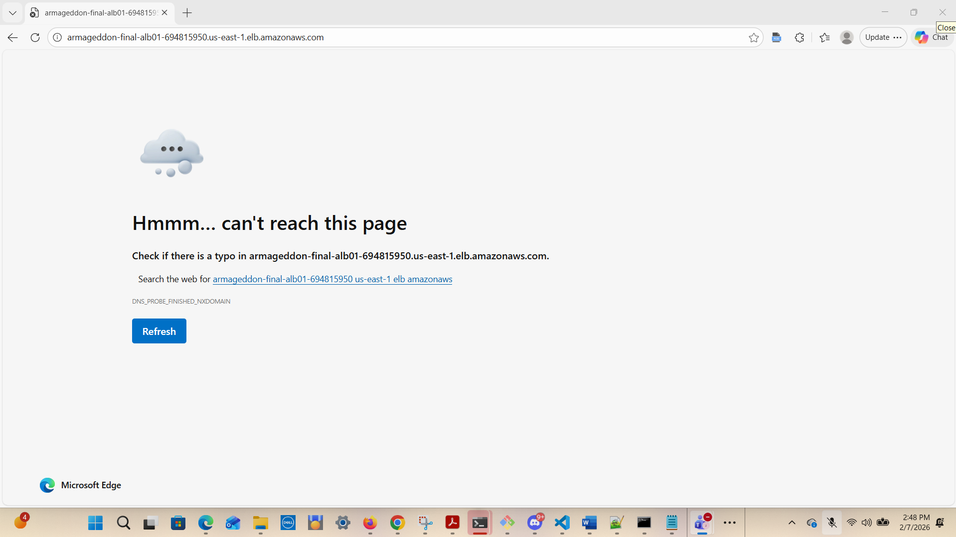
B) CloudFront access should succeed
curl -I https://chewbacca-growl.com
Ran: curl -I -k https://firstpointand.click
jorun@Simpkij3421 MINGW64 ~/documents/theowaf/armageddon/armageddon_repo/armageddon_clone/lab2_2a (main)
$ curl -I -k https://firstpointand.click
HTTP/1.1 502 Bad Gateway
Content-Type: text/html
Content-Length: 937
Connection: keep-alive
date: Sat, 07 Feb 2026 20:54:13 GMT
X-Cache: Error from cloudfront
Via: 1.1 3e9d4d15edc2b8776c7998392617fdb0.cloudfront.net (CloudFront)
X-Amz-Cf-Pop: ATL59-P11
X-Amz-Cf-Id: oNHDILvCEBHUvtBajBRjFmNYr8TH40SEOiat6SjF9ouHoW50zGKdsw==
jorun@Simpkij3421 MINGW64 ~/documents/theowaf/armageddon/armageddon_repo/armageddon_clone/lab2_2a (main)
RAN: $ curl -I --ssl-no-revoke https://firstpointand.click
OUTPUT:
HTTP/1.1 502 Bad Gateway
Content-Type: text/html
Content-Length: 937
Connection: keep-alive
date: Sat, 07 Feb 2026 21:01:14 GMT
X-Cache: Error from cloudfront
Via: 1.1 b1959df6404f714886531597a61cf8bc.cloudfront.net (CloudFront)
X-Amz-Cf-Pop: ATL59-P11
X-Amz-Cf-Id: 4ptVDu-W2240JZ1hYL1fAa3o11Mz23n_xdepmVerMaU-L9lM7ovTxA==
______________________________________________________________________________
curl -I https://app.chewbacca-growl.com
RAN: curl --ssl-no-revoke https://app.firstpointand.click
OUTPUT:
<h1>Lab 1b: Simple RDS App</h1>
<ul>
<li><a href='/init'>1. Init DB</a></li>
<li><a href='/add?text=LabEntry'>2. Add Note (?text=...)</a></li>
<li><a href='/list'>3. List Notes</a></li>
</ul>

Expected: 200/301 → 200
_____________________________________________________________________________
jorun@Simpkij3421 MINGW64 ~/documents/theowaf/armageddon/armageddon_repo/armageddon_clone/lab2_2a (main)
$ curl -I --ssl-no-revoke https://app.firstpointand.click
HTTP/1.1 200 OK
Content-Type: text/html; charset=utf-8
Content-Length: 233
Connection: keep-alive
Date: Sat, 07 Feb 2026 21:23:58 GMT
Server: Werkzeug/3.1.5 Python/3.9.25
X-Cache: Miss from cloudfront
Via: 1.1 979e13483501a9da34ceae4edaece53a.cloudfront.net (CloudFront)
X-Amz-Cf-Pop: ATL59-P11
X-Amz-Cf-Id: is2KsCzvDhfB9umeXiCC_vqAGdpDGtRZlrtmLWAJWYchrwD9yX-kmA==
jorun@Simpkij3421 MINGW64 ~/documents/theowaf/armageddon/armageddon_repo/armageddon_clone/lab2_2a (main)
$ curl -I -k https://app.firstpointand.click
HTTP/1.1 200 OK
Content-Type: text/html; charset=utf-8
Content-Length: 233
Connection: keep-alive
Date: Sat, 07 Feb 2026 21:26:12 GMT
Server: Werkzeug/3.1.5 Python/3.9.25
X-Cache: Miss from cloudfront
Via: 1.1 cef0837120f79784412d36f7eaef85a0.cloudfront.net (CloudFront)
X-Amz-Cf-Pop: ATL59-P11
X-Amz-Cf-Id: 8q8dRdcTeAk-hJlNQGyGu7jFAvqBgJns_3jmy1s4aUPBBbsoxoxz9Q==

2) WAF moved to CloudFront
aws wafv2 get-web-acl \
--name <project>-cf-waf01 \
--scope CLOUDFRONT \
--id <WEB_ACL_ID>

And confirm distribution references it:
aws cloudfront get-distribution \
--id <DISTRIBUTION_ID> \
--query "Distribution.DistributionConfig.WebACLId"

Expected: WebACL ARN present.

jorun@Simpkij3421 MINGW64 ~/documents/theowaf/armageddon/armageddon_repo/armageddon_clone/lab2_2a (main)
$ aws cloudfront get-distribution \
--id E21Z2AHO8WEHRH \
--query "Distribution.DistributionConfig.WebACLId"
"arn:aws:wafv2:us-east-1:975598471165:global/webacl/armageddon-final-cf-waf01/61ef6d70-4d2e-4a88-a780-379725ba5670"
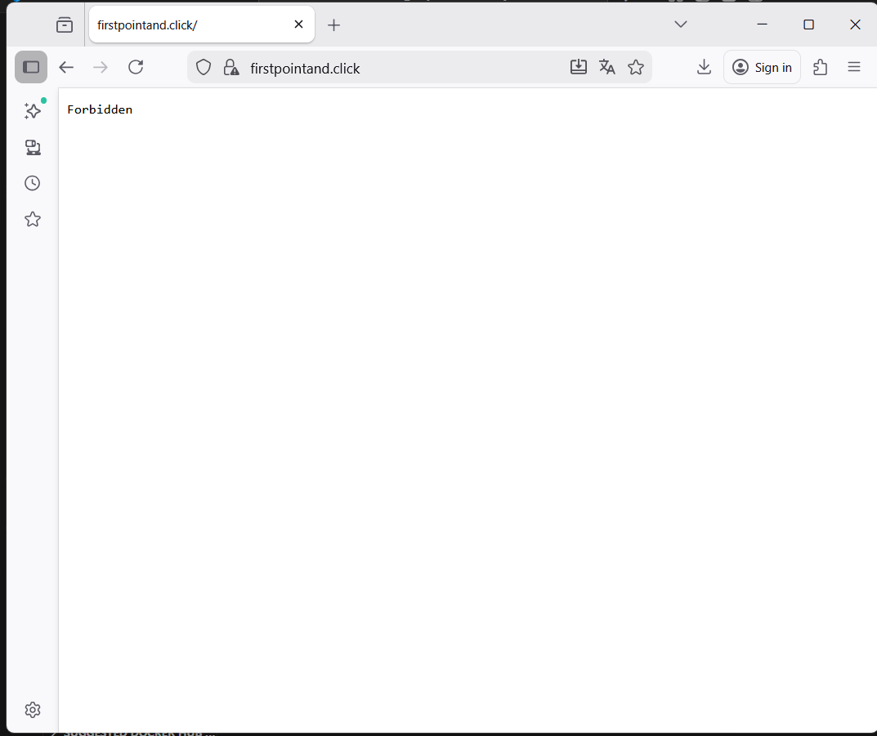

2) WAF moved to CloudFront
aws wafv2 get-web-acl \
--name <project>-cf-waf01 \
--scope CLOUDFRONT \
--id <WEB_ACL_ID>
OUTPUT:
jorun@Simpkij3421 MINGW64 ~/documents/theowaf/armageddon/armageddon_repo/armageddon_clone/lab2_2a (main)
$ aws wafv2 get-web-acl \
--name armageddon-final-cf-waf01 \
--scope CLOUDFRONT \
--id 61ef6d70-4d2e-4a88-a780-379725ba5670 \
--region us-east-1
{
"WebACL": {
"Name": "armageddon-final-cf-waf01",
"Id": "61ef6d70-4d2e-4a88-a780-379725ba5670",
"ARN": "arn:aws:wafv2:us-east-1:975598471165:global/webacl/armageddon-final-cf-waf01/61ef6d70-4d2e-4a88-a780-379725ba5670",
"DefaultAction": {
"Allow": {}
},
"Description": "",
"Rules": [
{
"Name": "AWSManagedRulesCommonRuleSet",
"Priority": 1,
"Statement": {
"ManagedRuleGroupStatement": {
"VendorName": "AWS",
"Name": "AWSManagedRulesCommonRuleSet"
}
},
"OverrideAction": {
"None": {}
},
"VisibilityConfig": {
"SampledRequestsEnabled": true,
}
}
],
"VisibilityConfig": {
"SampledRequestsEnabled": true,
"CloudWatchMetricsEnabled": true,
"RetrofittedByFirewallManager": false,
"OnSourceDDoSProtectionConfig": {
"ALBLowReputationMode": "ACTIVE_UNDER_DDOS"
____________________________________________________________________

And confirm distribution references it:
aws cloudfront get-distribution \
--id <DISTRIBUTION_ID> \
--query "Distribution.DistributionConfig.WebACLId"
OUTPUT:
jorun@Simpkij3421 MINGW64 ~/documents/theowaf/armageddon/armageddon_repo/armageddon_clone/lab2_2a (main)
$ aws cloudfront get-distribution \
--query "Distribution.DistributionConfig.WebACLId"
"arn:aws:wafv2:us-east-1:975598471165:global/webacl/armageddon-final-cf-waf01/61ef6d70-4d2e-4a88-a780-379725ba5670"
3) chewbacca-growl.com points to CloudFront
dig chewbacca-growl.com A +short
dig app.chewbacca-growl.com A +short
RAN:
dig firstpointand.click A +short
OUTPUT:
NOTE: ******dig – command was not on my windows command: PAINFUL…..!!!!!
Used: nslookup instead
jorun@Simpkij3421 MINGW64 ~/documents/theowaf/armageddon/armageddon_repo/armageddon_clone/lab2_2a (main)
$ nslookup firstpointand.click
Server: dsldevice6.attlocal.net
Address: 2600:1700:7de0:5ff0::1

Non-authoritative answer:
Name: firstpointand.click
Addresses: 3.170.73.76
3.170.73.99
3.170.73.128
3.170.73.96
OUTPUT:
NOTE: ******dig – command was not on my windows command: PAINFUL…..!!!!!
Used: nslookup instead
dig app.firstpointand.click A +short
jorun@Simpkij3421 MINGW64 ~/documents/theowaf/armageddon/armageddon_repo/armageddon_clone/lab2_2a (main)
$ nslookup app.firstpointand.click
Server: dsldevice6.attlocal.net
Address: 2600:1700:7de0:5ff0::1

Non-authoritative answer:
Name: app.firstpointand.click
Addresses: 3.170.73.99
3.170.73.96
3.170.73.128
3.170.73.76

Windows PowerShell
Copyright (C) Microsoft Corporation. All rights reserved.

Install the latest PowerShell for new features and improvements! https://aka.ms/PSWindows

PS C:\WINDOWS\system32> Resolve-DnsName firstpointand.click -Type A
>>

Name Type TTL Section IPAddress
---- ---- --- ------- ---------
firstpointand.click A 60 Answer 3.170.73.76
firstpointand.click A 60 Answer 3.170.73.128
firstpointand.click A 60 Answer 3.170.73.96
firstpointand.click A 60 Answer 3.170.73.99

PS C:\WINDOWS\system32> Resolve-DnsName app.firstpointand.click -Type A
>>

Name Type TTL Section IPAddress
---- ---- --- ------- ---------
app.firstpointand.click A 60 Answer 3.170.73.96
app.firstpointand.click A 60 Answer 3.170.73.76
app.firstpointand.click A 60 Answer 3.170.73.128
app.firstpointand.click A 60 Answer 3.170.73.99

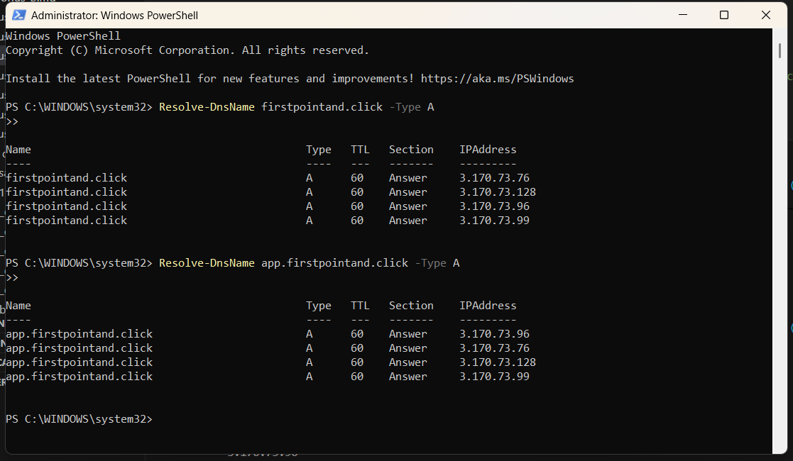

PS C:\WINDOWS\system32>

Expected: resolves to CloudFront (you’ll see CloudFront anycast behavior, not ALB IPs)

